REPORT OF THE PROCEEDINGS

Online Consultative Workshop

on

“LEGISLATING CLIMATE CHANGE LAW IN INDIA”

Organised by
Centre for Environmental Law, Education,Research and Advocacy, National Law School of India University, Bengaluru

Under
CEERA’s Initiative Towards Drafting a Climate Change Protection Bill
________________________________________________________
Date: June 18th, 2021
Our Websites: nlspub.ac.in nlsenlaw.org nlsabs.com

TABLE OF CONTENTS

ACKNOWLEDGEMENT 3
ABOUT NLSIU 4
ABOUT CEERA 4
ABOUT THE WORKSHOP 6
SUMMARY OF PROCEEDINGS 7
INAUGURAL SESSION 7
SESSION 1 8
SETTING THE AGENDA FOR THE WORKSHOP
CORPORATE GOVERNANCE AND NON-STATE ACTORS
SESSION 2: 11
PRESENTATION OF THE OUTLINE OF THE NLSIU CEERA CLIMATE PROTECTION BILL, 2021
PAPER PRESENTATIONS 19
PARALLEL SESSION 1
PARALLEL SESSION 2
SESSION 3: 30
CLIMATE CHANGE LITIGATION IN INDIA
SESSION 4: 34
CLIMATE WRONGS AND HUMAN RIGHTS
SESSION 5: 37
THE STATUS OF CLIMATE LEGISLATION IN AUSTRALIA: THE BROADER IMPORTANCE OF LEGISLATIVE PROVISIONS FOR THE RENEWABLE ENERGY SECTOR
SESSION 6: 40
LEGISLATING CLIMATE CHANGE LAW - LESSONS FROM SOUTH AFRICA
SESSION 7: 43
KEYNOTE ADDRESS
SESSION 8: 45
COMPARING THE EUROPEAN GREEN DEAL LEGISLATION PROGRAMME
SESSION 9: 46
CLIMATE INSTITUTION AND POLICY
LAW SOCIAL IMPACT AND CLIMATE CHANGE

ACKNOWLEDGEMENT
The Centre for Environmental Law, Education, Research and Advocacy (CEERA) would like to extend its profound gratitude to all the participants resource persons for their relentless support and contributions towards making the One-Day Consultative Workshop on Legislating Climate Change Law in India a success. In particular, we are thankful to Prof. (Dr.) M K Ramesh, our mentor and guide, for his relentless support and to our esteemed guests Hon’ble Mr. Jayant Sinha, Dr. Lisa Benjamin, Ms. Vidya Ann Jacob, Dr. Veena Roshan, Dr. Deevanshu Shrivastava, Mr. Shyam Divan, Prof. (Dr.) Arvind Jasrotia, Dr. James Prest, Dr. Urmila Soni, Mr. Andrew Gilder, Ms. Olivia Rumble, Prof. (Dr.) Kirk W. Junker, Prof. (Dr.) Navroz K. Dubash, Dr. Dilan Thampapillai and Dr. Manjeri Subin Sunder Raj.
CEERA would like to express its sincere gratitude to Prof. [Dr.] Sudhir Krishnaswamy, Vice- Chancellor, NLSIU for his encouragement.
CEERA also extends its sincere gratitude to Ms. Prathiksha Ullal, Mr. Koundinya Somayaji, Ms. Samikshya Mishra, Ms. Deepthishree K J, Ms. Deesha Reshmi, Mr. Chaitanya Pant, Mr. Aniket Singh, Ms. Avni Kritika and Mr. Shivam Bharadwaj for their contributions towards the Workshop.
Finally, we would like to thank the CEERA Team - Ms. Madhubanti Sadhya, Mr. Rohith Kamath, Mr. Raghav Parthasarathy, Mr. Vikas Gahlot, Ms. Geethanjali K.V. and Ms. Lianne D’Souza, for their help and support in organising this webinar and conducting it seamlessly.

Prof. [Dr.] Sairam Bhat
Coordinator, CEERA
Professor of Law, NLSIU

ABOUT NLSIU

The National Law School of India University, the nation’s premier law university, came into existence through a Notification under the National Law School of India University Act (Karnataka Act 22 of 1986). It signified the culmination of efforts by the Judiciary, the Bar Council of India, the Karnataka Bar Council, the Bangalore University and the Government of Karnataka to reform legal education and to establish a centre of excellence for legal education and research in India. The Law School has undertaken many research projects funded by the UGC, the Government of India, the Government of Karnataka, the Department of Women and Child Development, UN agencies, the World Bank, HIVOS, Department of Justice etc.
The projects have served to strengthen research and teaching at the Law School. The National Law School of India University since its inception has taken proactive steps in organizing conferences, seminars, workshops, refresher courses and certificate courses to update academicians, law teachers, students, industry personnel in different subject areas.

ABOUT CEERA

Centre for Environmental Law Education, Research and Advocacy (CEERA), established in 1997 is a benefactor of the Ministry of Environment, Forest and Climate Change (MoEF&CC), Government of Karnataka, the Bar and the Bench in India and abroad. Building an environmental law database, effectively networking among all stakeholders, building up an environmental law community and policy research in the area of environment are CEERA’s main objectives.
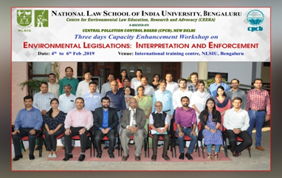
To achieve the aforesaid, CEERA has incessantly and successfully been able to build functional and professional linkages with government agencies and non-governmental organisations in India, the South Asian Region and at International levels. CEERA, has been partnering with the Central Pollution Control Board in organising Training Programmes for the officers of various State Pollution Control Boards and other industry professionals for over eight (8) years. One of the first in India, to be successfully granted a World Bank project and thereafter being a steady choice for the Ministry of Environment Forest and Climate Change, CEERA has been entrusted with research projects and workshops to impart training to Forest Officers, Revenue Officers, Officers of the Central Pollution Control Board and also of the Government of Karnataka. CEERA is proud to have completed a two-year Research Project granted by the United Nations Development Programme (UNDP) under the Global Environment Facility (GEF), and as one of the deliverables, organised, convened and conducted over twenty workshops at Institutions of national repute creating awareness on the Biodiversity Law and Access and Benefit Sharing (ABS) in less than 2 years. Two research publications on the scanty research area of biodiversity laws were also the outcome of this project. CEERA is currently implementing a Three-Year Project granted by the Ministry of Environment, Forest and Climate Change titled “Collaborative Engagement for Research, Training and Development in Handling of Chemical and Hazardous Waste”. The broad objectives of this project inter alia include, providing advisory to the Ministry on matters connected to the Conference of Parties under various Multilateral Environmental Agreements, to which India is a party.
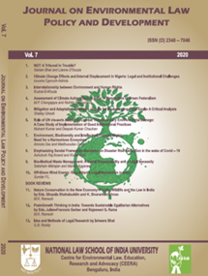
CEERA has several publications in the area of environmental law, the law and public policy along with Newsletters, CEERA March of the Environmental Law, NLSIU’s first e-Journal – Journal on Environmental Law, Policy and Development and manages three websites viz., www.nlsenlaw.org, wherein the law and policy on environment is regularly updated, and www.nlsabs.com, a dedicated portal wherein the law and policy on Biodiversity Access and Benefit Sharing is updated periodically. All our publications are duly updated on our online portal www.nlspub.ac.in, which is open for subscription to all readers.

ABOUT THE WORKSHOP
In the attempt to join the global effort to address climate change and its allied issues, Centre for Environmental Law, Education, Research and Advocacy, NLSIU has undertaken the initiative to draft a Bill that seeks to provide a clear and comprehensive framework for climate protection in India. To this end, CEERA had organised a One-day Consultative Workshop on Legislating Climate Change Law in India on 18th June, 2021.
The Workshop was aimed at creating a platform to stimulate intellectual discourse on critical issues associated with climate change and to identify viable solutions to address these issues. With the participation of experts in the relevant area of study and other stakeholders, the workshop was designed to draw from different perspectives and disciplines apart from the legal perspective of climate change. Given the absence of an explicit law in India addressing climate change, the workshop specifically aimed to advance the dialogue on devising a comprehensive legislative framework that addresses climate change in India. Furthermore, the workshop was unique in its range and breadth as the discussions focussed on the need to provide protection against climate change and the legal means to achieve the same.
With the objective of identifying the varied dimensions of enforcing a law on climate change protection, the workshop presented the draft framework of the CEERA NLSIU Bill on Climate Protection and deliberated on some of the core principles and ideas envisaged under it which are as follows:
- A decentralized approach for climate risk mitigation and adaptation.
- The institutional structure for climate change governance.
- Identification of vulnerable communities with a view to advance protection and rehabilitation measures
- Efforts towards rehabilitation of vulnerable communities
- Climate Sustainability Plan for institutions and projects likely to gravely impact climate change
- ‘Climate Risk Insurance’ to meet the needs of vulnerable communities.
- Climate Education and Climate Awareness to encourage dissemination of knowledge and create awareness on the effects of Climate Change.

SUMMARY OF PROCEEDINGS



INAUGURAL ADDRESS


The Online Consultative Workshop on ‘Legislating Climate Change Law’ commenced with an introduction by Prof. (Dr.) Sairam Bhat by extending his warm welcome to all the delegates and participants. He spoke about the importance and the need for the climate change legislation. He concluded by providing encouragement to all the participants to have an interactive workshop. Next, a welcome address was provided by Ms. Madhubanti Sadhya, Teaching Associate, CEERA, NLSIU. A brief introduction about the Centre’s activities, initiatives and research projects was given to the participants.

SESSION 1

Setting the Agenda for the Workshop Corporate Governance and Non-State Actors


Prof. (Dr.) M. K. Ramesh, Professor of Law, NLSIU, Bengaluru then discussed the importance of the workshop as a platform for discourse and dialogue about critical climate change issues and the role the Centre hopes it will play in reaching the goal of framing a robust law for climate justice in India. Throwing light on the Paris Agreement, he spoke about how the Agreement has scarce elements of climate justice and action as a follow up. Turning to India, he stated that the existing laws do not take into account the changing sector wise scenario and hence, are obsolete. He introduced the draft bill by Jayant Sinha, Hon’ble Member of Parliament and commented that the draft’s vision has a limited focus rather than being compelling. It is at most a persuasive tool. Thus, the need for a more impactful legislative effort that would seek climate justice still remains. Drawing comparisons with world models, he stated that there are many that India can look at for inspiration. However, with each international model, conformity to the Paris Agreement rises. They hardly match the objectives of the UNSCC. Lastly, he laid down the issues that would be deliberated upon in the workshop, the questions that would be raised by the speakers and set the tone for a fruitful discussion led by the CEERA with the objective of creating a robust dialogue and help in evolving a modern Bill that serves as a template for climate injustice laws everywhere.


Taking over from Prof. (Dr.) M. K. Ramesh, Dr. Lisa Benjamin, Assistant Professor at Lewis and Clark Law School, Portland, Oregon who commenced her speech by taking the participants through a snapshot view of the latest developments around Europe and the USA with the purpose of explaining how the same could be replicated through litigation or included in legislation in India. In terms of the traditional approach to corporate climate liability, she suggested that a company doing some extractive business in India could be registered in the NYSE or the LSE so it would be sensitive to jurisdictions all around the world. Thus, the traditional approach has always revolved around the regulatory license to operate (permits from the Government of India), economic license (profitability for shareholders) and the social license to operate. It is always the economic license which is focused on the most – at the expense of the social license. Thus, we’re faced with climate controversies caused largely due to corporate activities. She emphasized on how oil and gas companies are on the sharp end of the liability spectrum. Corporate response has basically come in the form of CSR and issuing sustainability reports with vague, boilerplate statements. In fact, a group of oil and gas companies formed the GCC (Global Climate Coalition) which was later disbanded as it was heavily criticized for the constant lobbying towards minimal climate change regulations. At the same time, there is international law such as the OECD Guidelines for MNEs and the UN Guiding Principles on Business and HRs which is binding only on states. Therefore, for a long time, these were seen as soft laws and were not really used by courts to attach liability to corporations and the UN, in particular, responded with many global initiatives for ensuring non-state actors took liability for climate damage. The first real change that impacted the international perspective on corporate liability was the groundbreaking Carbon Majors Report by Richard Heede in 2014 followed by the Paris Agreement in 2015. Subsequently, the TCFD (Task Force on Climate-related Disclosures) was formed which published a list of recommendations which quickly became the international standard. It has even been made mandatory in some countries. In 2019, the Intergovernmental Panel on Climate Change (IPCC) published a report titled, ‘Global Warming of 1.5℃’, which remains as one of the most significant reports ever published by the organization. She highlighted speeches made by the UN General Secretary and the Friday protests that school children did to raise awareness about climate change.

In terms of the recent developments regarding regulatory licenses in the USA, she listed the Baltimore decision of the US Supreme Court (May, 2021) as an example of the reluctance of the Supreme Court to get involved in climate regulatory issues. She then stated how the executive order issued by the Biden administration is the first significant regulatory action in the US for financial federal agencies to act upon. Further, in terms of economic license developments, BlackRock’s statement to CEOs issued in 2020 assumes significance. Moreover, the shareholder proposal made by Engine No. 1 in May, 2021 was accepted by a majority of the shareholders of ExxonMobil, a corporation that has never really taken responsibility for any climate change activity. Chevon, at the same time, received similar shareholder proposals.

Moving on to the developments in the UK, she shared a list of cases that had gradually replaced the traditional approach of piercing the corporate veil. Since 2012, the principle has been replaced by ‘duty of the parent company’. This new principle developed in the Chandler v. Cape (Court of Appeal) case wherein 4 factors were established – business of the parent and subsidiary are in a relevant respect the same, the parent has superior knowledge, it knows the subsidiary’s system is unsafe and it know the subsidiary would rely on its superior knowledge. The duty of the parent company that was established in the case has undergone quite a few changes, Next, she highlighted the Lungowe v. Vedanta case wherein the locals around a subsidiary company based in Zambia sued the parent company for environmental pollution that affected the community.

Coming to the EU, she spoke about the RWE v Lliuya case where a local sued the company for damage to a lake in Peru due to climate change. More importantly, she mentioned the recent case of Royal Dutch Shell v Milieu Defensie (2021) where Shell was told that under tort law, they had to reduce their emissions. The courts relied heavily on the Heede report and the IPCC 1.5℃ report cited above. They also relied on the international law that was considered to be too soft and applicable only on state actors. The court stated that Shell had a legal obligation which it labelled as the ‘best efforts obligation’ to reduce emissions by 45% by 2030. Conclusively, while the company stressed on its economic license to operate, the courts held that the climate risks are so high that they outweigh Shell’s so-called economic license.

She wrapped up her speech by stating that the future will definitely see more jurisdictions making climate risk disclosures mandatory. Litigation in the EU with respect to corporate climate liability is another thing that might dial up in the future. Companies might transition to natural gas and try to keep the viability of their natural gas operations for as long as they can. The social license to operate is also going to become more urgent as the impacts escalate. Lastly, she remarked that a rethink of the business models for fossil fuel companies is the need of the hour and would largely benefit both the society and the corporation in the long run.

SESSION 2

Presentation of the Outline of the NLSIU CEERA Climate Protection Bill, 2021

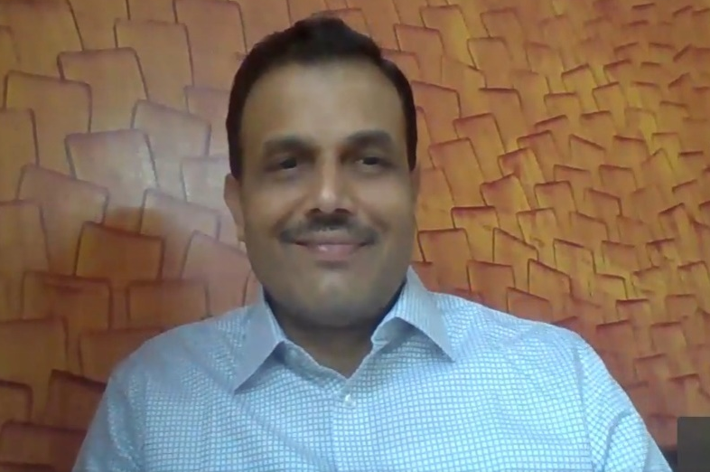
This segment began with Prof. (Dr.) Sairam Bhat providing a background of the draft bill. In the year 2020, there was a public health emergency and a climate emergency declared by the WHO and the UN secretary general respectively. These two subjects of climate change and public health are inseparable and thus any law on climate change has to address the challenges of public health. Moreover, the battle for climate justice is not one which can be fought territorially. India, as a growing superpower, must emerge as the regional leader in the SAARC region in terms of climate justice. This legislation is an important stepping stone towards such regional leadership. The other reason for bringing about this legislation is also the fact that there is a lacuna in the present legal framework. An ideal climate change legislation should address the impact of natural disasters on lives, livelihood, property, and livestock. These are some of the perspectives inculcated in the bill which will institutionalize climate justice and bring a change in the management structure of governance.

Next, Ms. Lianne D’Souza explained the Statement of Objects and Reasons of the bill. The bill is envisioned to protect stakeholders and combat climate change. That is why, placing due consideration to India’s topography and the communities that it puts into risk, protection is sought to be given to these vulnerable communities. Next, as India is a party to the United Nations Framework Convention on Climate Change (UNFCCC), the Kyoto Protocol, and the Paris Agreement, there are numerous obligations imposed on it as a party. The bill is designed to meet these obligations and ensure India meets its capacity by minimizing the effects of climate change. Finally, the bill sets in place a framework which sets a regulatory mechanism for implementation of its provisions.



Moving on, Ms. Lianne discussed the concept of vulnerable communities. The need for identifying vulnerable communities stems from the fact that India ranks 89th in the World Risk Report of 2020. India needs to improve its stance in bracing itself and one way of doing this is by protecting those communities which stand to lose the most from the climate change induced threats. Under the bill, a vulnerable community is any such “community who is susceptible to or has been exposed to climate change related hazards and risks”. Such risks could arise out of two factors, firstly, a drastic climate event or secondly, extreme climate variability which is distinct from the existing factors that influence the climate of the region. The reason for inclusion of the second factor was that India has a myriad variance when it comes to topography. It is necessary to exclude the recurring threats of climate change such as that of flooding in coastal areas from other disasters. Moreover, protection to such communities would not be divested from them merely because of non-observance of any measure by them since many of such communities are poorly situated in the socio-economic strata.

Ms. Lianne then explained the concept of drastic climatic event. Vulnerable communities are defined on the basis of such events. Because of the cross-cutting nature of climate-change related risks, the definition of a drastic climatic event cannot be put in a water-tight compartment and has to be of a broad nature. Hence, it is any disaster of an unprecedented arising out of climate change related impacts which causes injury to life, limb or property.

Next, Ms. Lianne explained the process of classifying a community as a vulnerable one. The local body/state government is tasked with the responsibility of making the application. The Climate Protection Commission of India [hereinafter “CPCI”] which this bill establishes, will be engaged in the task of preliminary appraisal of the application. There are multifarious inclusive factors which the CCCI will consider for the purposes of such appraisal which are—
- exposure to climate variability and change,
- adaptive capacity of the community;
- measurable economic loss;
- community scale determinants which are measured on the basis of—
- income and distribution
- access to technology
- available climate information and risks
- risk perception and awareness
- stock of social capital
- critical institutional frameworks at the community or regional level
- existence of maladaptive behaviours informed by customs or traditions that increases vulnerability
- environment factors namely—
- historical climate data and variability
- availability and utilization of natural resources

Then, for the purpose of democratizing the process, there will be a public disclosure of the application. Once the community is identified as a vulnerable one, it will be entitled to reliefs.



Ms. Madhubanti Sadhya then explained the reliefs that are envisaged for the vulnerable communities. There is a four-pronged approach taken towards protection of vulnerable communities. These are protection of life, environment, and property, and the duty of the state to pre-empt climate change. The kinds of reliefs that will be awarded is compensation, adaptation, and rehabilitation relief. Although quantifying loss will be difficult, as a welfare state, India needs to adopt compensation as one of the reliefs. Adaptation is necessary for people from the lower socio-economic strata who rely on the natural resources for the purposes of sustenance. Finally, rehabilitation is needed because of land-loss and in the long-scheme. This also includes eco-system restoration.

For the purposes of determining amount of money to be given as monetary compensation, the CPCI will consider—
- loss of life or limb
- loss or damage to property – moveable/immoveable
- economic loss – medical expenses and loss of livelihood
- non-economic loss
- mental and emotional trauma and suffering
- damage to natural resources essential for survival
- marketable natural resources
- non-marketable natural resources
- other consideration
- age, family size, and number of dependants
- average salary or wage earnings
- recent earnings

The CPCI may take a note of all or any of these factors.

Parameters that the CPCI will take into consideration for deciding the kind of relief which will be awarded are—
- Proximity to geographical terrain susceptible to drastic climatic events.
- Frequency of drastic climate events in the specific geographical location.
- Imminent risk, exposure, and hazard of the drastic climate event faced by the vulnerable community.
- Extent of economic and non-economic loss and damage suffered.
- Nature of the past relief and the extent of its distribution post the drastic climate event faced by the event.
- Strength of local, municipality governance structures.
- Strength of critical healthcare infrastructure, level of connectivity and developmental opportunities available for the vulnerable community.
- Level of community awareness and knowledge of climate change related impacts and disasters.
- Existence of customary maladaptive behaviours.
- The adaptive and collective coping capacity of the vulnerable community.
- History of rehabilitative efforts and kind of measures implemented in the past.
- Major source of livelihood and sustenance of the vulnerable community, and its ability to sustain themselves in the eventuality of migration/relocation.
- Critical ecosystem depletion in areas where the vulnerable community resides.

Dr. Bhat placed emphasis on the fact that the name of the bill is Climate Protection Bill and not Climate Change Bill because its scope is not restricted to just achieve zero carbon emissions, but it will have a positive approach towards the rights of the citizens. The reliefs granted in the current framework are clearly inadequate and are at the discretion of the state. The Climate Protection bill looks at the positive duty of the state towards its citizens as the state owes a responsibility to protect its citizens

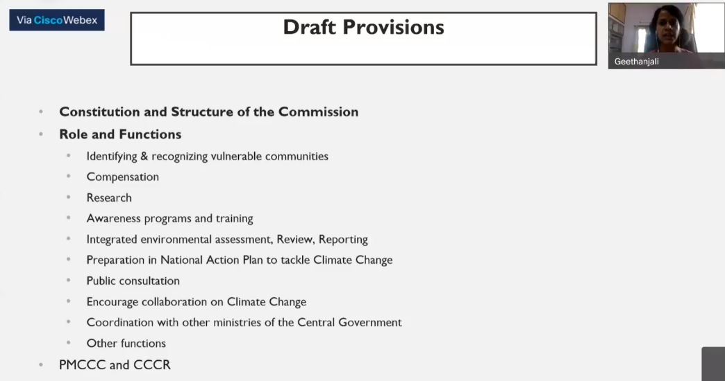

Next, Ms. Geethanjali K V discussed the purpose and objectives of CPCI. The requirement to set it up stems from the fact that there is a need for an independent body which can conduct environment impact monitoring and provide evidence-based advice. It is proposed to be a will be a statutory, non-executive, advisory, coordinating body. To establish it, references are taken from the U.K., Spain, Australia, New Zealand, Denmark, Kenya, and the U.S. where the commissions are independent advisors to their respective governments. The climate change law of New Zealand even mandates that the members constituting its commission have the knowledge and skills relevant to its indigenous community to ensure that a holistic approach is taken.

Following this, she spoke about the constitution of the CPCI. To ensure an inter-disciplinary approach, The MoEF&CC will appoint the chair, and the commission’s secretaries are appointed with the consultation of Ministry of Power, Ministry of Agriculture & Farmers Welfare, Ministry of New &amp; Renewable Energy, and National Disaster Management Authority. Members from the private and public sectors are also appointed.

The role and functions of the CPCI will involve mobilizing the local governments to document the vulnerable communities. The CPCI will approve the classification of a community as vulnerable after consulting the Committee of Experts [hereinafter “CoE”], another body proposed to be set by the bill. This CoE will constitute of scientists, researchers, climate change experts, NGOs working in the realm of climate change, etc. After the body finalizes its recommendations with regards to the classification of the community, it is tabled before the MoEF&CC. Any dispute with respect to this will be heard before the National Green Tribunal.

She said that the CPCI also has the responsibility of sensitization and training of personnel who are in the forefront of tackling climate change. Collaboration with organizations such as Indian Council for Agricultural Research, Indian Forestry Institute will prove to be fruitful. Another responsibility that the CPCI will have is to table a report before the parliament every year. This report will consist comprehensive analysis of the country’s environmental policy, its effectiveness, and implementation. Moreover, every five years, the CPCI will prepare a State of the Environment Report which will analyse the environmental trends. The research undertaken by the commission will supplement into the preparation of the National Action Plan and National Climate Change Adaptation Plans. These plans will be formed after undertaking a risk-assessment of the present and future and will design steps to better cope with them.

The bill encourages the CPCI to include public and private collaboration at each level in order to avoid conflicts at the stage of implementation. Ms. Geethanjali drew a parallel between the U.S. Climate Equity Bill, 2020 and the draft bill. A nodal officer is to be appointed by the CPCI in all the ministries who will co-ordinate between the CPCI and the ministries for implementing the bill. Moreover, no legislation should be introduced before the parliament without consulting the CPCI which will conduct a thorough analysis of the environmental impact of such bill.

She then differentiated between the Prime Minister’s Council on Climate Change [hereinafter “PMCCC”] and the CPCI. The PMCCC has several lacunas in its functioning. As it was set up under the National Action Plan for Climate Change, it has to work under that restricted scope whereas CPCI will be a statutory, non-executive, advisory, coordinating body. Also, PMCCC reports to the PMO who then co-ordinates with the other ministries. The proposed CPCI will directly report to the MoEF&CC who will take due actions. She also differentiated the Centre for Climate Change Research [hereinafter “CCCR”] from the CPCI. The ambit of CCCR is only scientific research whereas CPCI involves scientific and policy-research, impact assessment, and rehabilitation. CPCI envisages to fulfil India’s international obligations whereas CCCR does not have such a mandate.

Dr. Bhat brought the listeners’ attention to the fact that the current legal framework does not bestow upon citizens the right to environment, climate adaptation, climate mitigation, or compensation. He quoted, “climate change is everywhere but nowhere.” An independent autonomous body is the need of the hour.

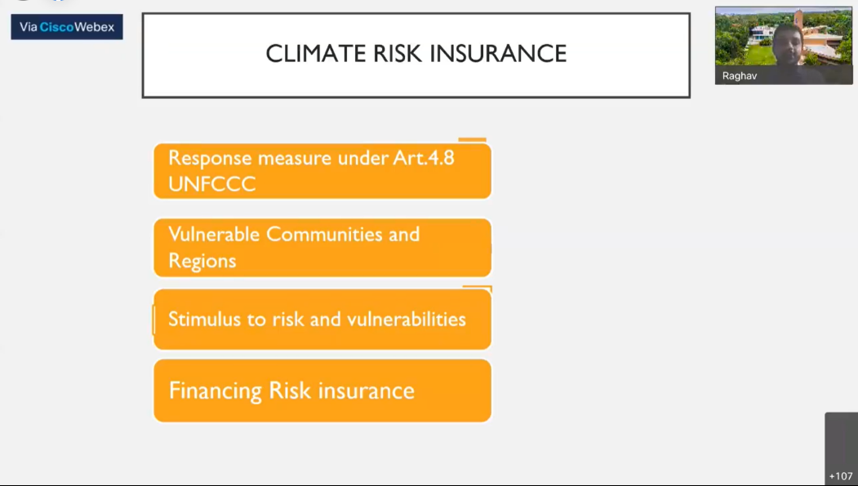

Next, Mr. Raghav Parthasarathy explained the concept of climate risk insurance. Several parameters exist in the assessment of whether climate risk insurance is necessary. One of which is the identification of the vulnerable regions. Under the article 4.8 of the UNFCCC, climate risk insurance is one of the measures identified. As a welfare state we also need to identify vulnerable communities and well-equip them. A risk insurance is one of the means of doing so. It means a pre-disaster financing agreement and shifts the economic risks from one party to the other. However, paying heed to India’s myriad variance in topography, a single type of climate risk insurance cannot be adopted and it should be an inclusive approach.

There are three types of insurance schemes that the bill proposes— micro insurance scheme, meso-insurance scheme, and macro insurance scheme. Micro insurance scheme provides protection to low-income households against disasters arising out of climate change. They will have to pay a small premium for these purposes. A meso insurance scheme is for the financial institutions which provide financial assistance to the vulnerable communities. Macro insurance scheme is a reinsurance instrument at the national level and given by international bodies.

Next, he explained stimulus to risk and vulnerabilities. This becomes the government’s duty to identify the risk faced by each of the vulnerable communities. Such risk assessment helps in anticipation of a particular event and designing a risk insurance. The burden of financing a risk insurance can be imposed on such entities which are the most responsible for generating carbon-emissions which are the industries. Even the sovereign disaster risk fund may be set-up and exploited for this purpose.

Dr. Bhat explained that there is no framework in the present for the purposes of a climate risk insurance. There are only piecemeal efforts such as crop insurances. Other aspects of health, property, life are not covered yet.

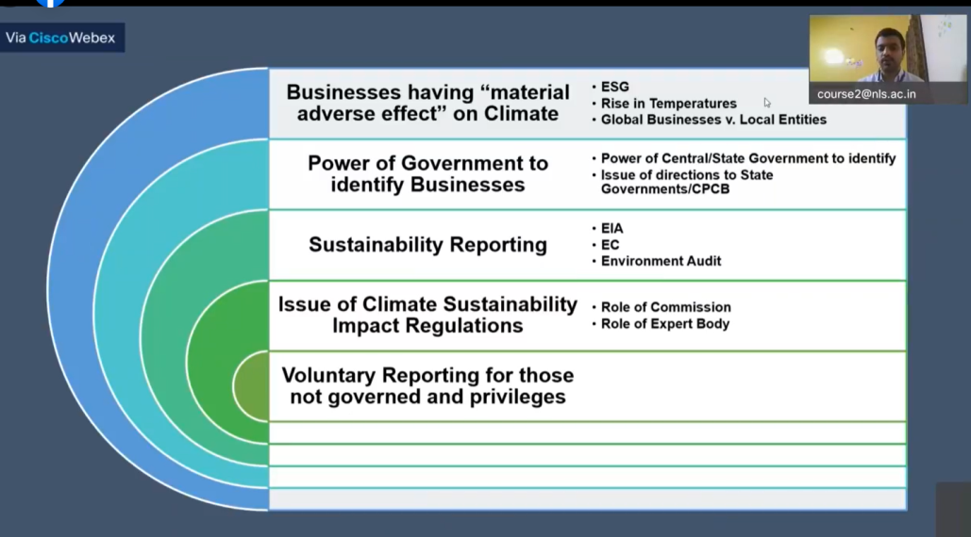

Next Mr. Rohith Kamath started his discussion by explaining the concept of governance and sustainability framework. The need for this framework is because of two factors, firstly, greenwashing, which is an activity undertaken by miscreants who try to portray that their products are sustainable for the environment when they are actually hazardous. Secondly, IoT and the creation a repository of data will provide an avenue for creative solutions in combating climate change. Businesses having “material adverse effect on climate” will be identified on the basis of carbon emissions generated, impacts on soil fertility, etc. A corporate governance framework will try to create transparency so that attempts of greenwashing are exposed. The state and the central governments would have the power to identify industries which cause material adverse effect on climate. This will be done on the basis of the parameters in the definition.

Then he explained what sustainability reporting under the framework would be. This would cover prior the activity, during the activity, and post the activity so that the entire life cycle of the industry is reported. This would assist in granting environment clearances. Since the framework would only cover those who materially adverse the environment, there is also a concept of voluntary reporting for those who are not governed by it.

Dr. Bhat spoke about how a legislation should try its best to reduce litigation. This legislation will not only bestow right on its citizens and impose corollary duties on the state, but it will hold accountable the non-state actors as well. Every industry should annually come up with a plan under a legislative framework for reducing their emissions and adhere to it.

PAPER PRESENTATIONS

Parallel Session 1

Parallel Session 1 of the paper presentations was chaired by Dr. Veena Roshan, Assistant Professor. National Law University -Jabalpur and Co-Chaired by Ms.Raagya Zadu, Doctoral Scholar, National Law School of India University , Bangalore . Nine papers were presented in this session the abstracts of the papers have been presented below:
- CLIMATE LITIGATION AND PRO-ACTIVE JUDICIARY IN INDIA - Dr. N.Kayalvizhi

“Small actions Lead to Big actions”

The pandemic Covid-19 Bio-warfare plagued the entire World. Its, outreach has shaken the universe. India is witnessing drastic climatic changes since then. The Global climatic change report reveals that there is a rapid increase in the Climate change litigations of the world. The report calls for greater climatic disclosures than corporate Green washing. In the beginning of the year 2020 , Indian courts initial approach was lackadaisical to decide any of the upcoming climate related cases , For instance migrant issues. Severe criticism led the Supreme judiciary, subordinate courts and tribunals to opt for proactive approach.

The presenter outlined that there exists a need for a paradigm shift where Judges need to think outside the Pandora box and ensure that decision towards climatic change is implemented to the fullest. The presenter purported to make the assessment of the Climate Change Litigation cases relating to Carbon footprint, green house gas emissions, clean energy mechanism and cases that deal with International negotiation and directions that direct the government to be ambitious and through on climate change. Further the relevant precedents on climate change and the critical analysis of climatic concerns were highlighted for reference.
- CLIMATE CHANGE IN INDIA - Dr. Misha Bahmani

Unfortunately, many nations are badly affected by climate change and their growth has slowed. Recently, India is struggling in maintaining a good quality of air despite lockdown during the COVID-19 pandemic. Having clean air to breathe is a “basic human right” that at present needs to be protected. Sadly, due to air pollution lives of many people have become worse. The health crisis in India has been raised due to climate change and its impact on its resources. Soil pollution has worsened the quality and quantity of crop production in India. Many areas are deprived of clean and safe water for consumption. The groundwater level is very low in warmer areas. The monsoon pattern has been changed in India which has forced the farmer to different grow crops this has affected their income and production level.

This shows climate change has badly impacted the growth and safety of natural resources in India. Sadly, there has been insufficient food supply and lesser shelter facilities due to climate change Dr. Bahmani explained that there has been displacement of the public because of the non-availability of natural resources and an unhealthy environment. Under such an unpredictable climate there has been a surge in the number of cancer patients and respiratory infections. To highlight the danger attached to climate change, Environment Day is an initiative to create public awareness about the challenges which the climate is facing at present and how it would impact future generation growth if rigid actions and precautions are not taken by the public at present. Presenter also mentioned that people need to open their eyes before it’s “too late” for them to survive. The ecosystem needs to be protected which can be achieved by providing an effective irrigation system, sustainable transportation system, and encourage the use of renewable sources. There is a need to protect India from global warming, temperature, and sea level rise. India in 2021 has been positioned seventh in the Global Climate Risk Index which has placed this nation in an alarming stage.
- NEGOTIATING TOWARDS DOMESTIC CLIMATE CHANGE LEGISLATION COVERING INDC AND SUSTAINABLE ECONOMY IN INDIA - Ashutosh Kumar

Mr. Kumar highlight how India is going to utilize the global climate change fund to be released on its name. How the fund requires accountable and transparent accounting system which can only be possible when, it has coherent constitutional framework of harmonizing of international environmental law with domestic law following the mandate of Art 51 and art 253 of Indian Constitution for proper, progressive development of International law for common concern of mankind and planet.

Identifying the need either to unify all environmental legislation by adding climate change issues expressly or to enact new robust Climate change legislation by making inclusion of climate change fund administration for proper climate finance atmosphere, using it for creating capacity building, technology transfer for climate resilient ecosystem aiming proper channelization of resources in sustainable manner such that it may not create confusion and become ground of corruption. This presentation covers vital indicators which had to be included in climate change domestic legislation.

- CLIMATE CHANGE – ROLE OF CORPORATES AND CORPORATE GOVERNANCE - Vidjealatchoumy V

“When the Last Tree Is Cut Down, the Last Fish Eaten, and the Last Stream Poisoned, You Will Realize That You Cannot Eat Money” - A Native American Saying

The presenter discussed about the Environmental obligations of the corporates and as to whether the environmental laws and the actions envisaged by such laws are sufficient deterrents to the corporates that violate. We have number of Acts and rules that deal with environmental obligations and liabilities of corporates like Environment (Protection) Act, 1986, The Forest (Conservation) Act, 1980, The Biological Diversity Act, 2002, Bio-Medical Waste (Management and Handling) Rules, 1998, Hazardous Wastes (Management and Handling) Rules, 1989, The Water (Prevention and Control of Pollution) Act, 1974, The Air (Prevention and Control of Pollution) Act, 1981, The Companies Act, 2013 etc. The above list is not exhaustive.

Corporates have the biggest share in greenhouse gas emission, which retains the Sun’s heat in the atmosphere resulting in global warming, heating up the planet. Most of the Companies and the Corporate Governance Stakeholders do something with respect to the Environmental protection, either for the sake of fulfilling the legal mandate or just to please the enforcing authorities. The presenter outlined that even the Polluter Pays principle is a doom to the environment, because the companies know that they can get away with the liability upon committing an offence against the environment by paying a fine, more often get away with it very easily and comfortable, with the amount of piled up cases and judicial delay. In the opinion of the researcher, the treatment should be something like Polluter Pays and Quits Principle.

Mrs. Vidjealatchoumy V put forward that even though India has almost fulfilled the International Commitments towards Climate change mitigation and adaptation with respect to the Paris Convention, that it is very imperative that the Environmental obligations of Corporates are brought under a unified code of law on Climate Change that aims at mitigation and adaptation of Climate Change in India. Through this, the responsibilities towards nature and environment may be totally internalized in the Corporate Governance Regime, apart from merely achieving the corporate goals and just giving back to the society through CSR.
- PROTECTION OF CLIMATE CHANGE REFUGEE UNDER INTERNATIONAL LAW: A CRITICAL ANALYSIS - Apoorva Vednarayan Misra

It is an undisputed fact that environmental degradation will generally affect people from the Global South due to its vulnerability, dependency on natural capital, lack of financial and physical capacity to adapt to climate change. Further, climate change has a horrendous adverse impact on the developing and most specifically on the under developed countries and Small Island Pacific countries (SIP) or Low-Lying Countries. Ms. Misra discussed various studies and reports issued by the international institutions, have significantly highlighted that majorly Women, Children and Indigenous people will be the most affected group of our society that are affected by the catastrophe of climate change.

Global North (developed countries) has been considered to be the major exploiter of natural resources available in the Global South or “Developing Countries” and/or “Under developed Countries” due to their colonial idea of development which has largely affected the natural resources and ecological imbalance in the Global South. Hereby raising very challenging questions before us. To quote few, who is the perpetrator and Victim? whether the Global North, should primarily bear the responsibility for providing asylum to the victims?

The conflicting issues of Human Rights and Sovereignty and may more. Even after so many years we are unable to form any guiding principles or adequate policy to bring relief to the victims of climate change. This further leads to various set of question which author intend to highlight in the article. However, the problem of climate change and the consequent, Climate change refugees can no longer be ignored by the international community.
- NATIONAL AND INTERNATIONAL EFFORTS TO COMBAT THE EFFECTS AND IMPACTS OF CLIMATE CHANGE - Tajmul Karim

Mr. Karim outlined that climate change is an important issue in front of humankind and how human beings are affected by changing of climate. The effects of changing climate are very serious and evil for the mankind. Various problems are arising due to effect and impact of climate change. Such as, global temperatures rising, rising in Sea level, decreasing snow cover, flooding in coastal areas, shortages in water supply for public etc. In this circumstances environmental and climate Sustainability is the most important and essential goal of the present world. The Environmental scientists are very anxious to think the matter that how it can be prevented and how it will be possible to bring back the natural environment and climate sustainability.

United Nations Framework Convention on Climate Change (UNFCCC) had opened for signature in Rio Earth summit, 1992. The main aim of this Convention was to reduce the impact of Green House Gas Effect on climate change. The framework provided by UNFCCC to deal with climate change issue, came into force in 1994. After that, Kyoto Protocol had been adopted in 1997, to implement the decision which had been taken in UNFCCC. Kyoto Protocol came into force on 16th February, 2005.

The main aim of this protocol was mandatory target for reduction of Green House Gas emission. India has also adopted National Action Plan on Climate Change (NAPCC) in 2008. This National Action Plan included eight national Mission. Such as Jawaharlal Nehru Solar Mission to develop solar energy, National Mission for Sustainable Habitat to make sustainable cities, National Mission for Sustainable Agriculture to develop sustainable agriculture as a climate resilient system etc. In this backdrop, the presenter analyzed the various National and International Steps to obstruct the effects and impact of Climate Change.
- CLIMATE VULNERABLE GROUPS: IN NEED OF RIGHTS BASED PROTECTION – Nabanita Sen

The Global Goal of the Sustainable Development Goals (SDGs) broaches an urgent call to combat climate change stress globally. The UN Refugee Convention, 1951; stipulates that a person has to be displaced by fear of persecution on grounds of race, religion, nationality, membership of a particular social group or political opinion, fails to extend its ambit for climate displaced vulnerable groups. Climate activist Swedish vociferous teenager Greta Thunberg alerts the world of massive far-reaching climate change threats that just not only endangers human survival but crops crisis of food, water, housing, livelihood, productive assets and health. Ms. Sen outlined how this triggers human security, disregards human dignity and jeopardizes a spectrum of human rights of millions of people displaced across borders by negatively impacting their right to life and right to healthy environment. Fragile governing bodies reluctant to address human rights protection gap that exist for population forced to migrate by rapid adverse climate change factors exacerbate environmental challenging disruptions.

Resorting to judicial machinery to hold accountability of corporations and governments by addressing climate change crisis as human rights crisis would pave the way for climate justice. The presenter identifies terminological, conceptual lacuna and frames the need to amend the Refugee Convention, 1951 while suggesting wide interpretation of the scope in order to include the climate change vulnerable groups within its periphery.

Ms. Sen tried to uphold that the legal normative framework of climate change induced displacement of vulnerable groups has dodged attention. Appallingly, the status of legal protection of climate change induced vulnerable groups or climate migrants or climate refugees or environmental refugees seem uncertain and ineffective under the legal regime as they find no place in any legal definition of refugees.

The presenter seeks to propose an independent legislation or a sui generis convention to indemnify and protect the needs of the marginalized displaced community. This paves an avenue to ensure rights-based protection to the climate displaced groups which calls for humanitarian solidarity with comprehensive approach and committed co-operation to human mobility at global level.
- JUSTICE FOR CLIMATE REFUGEES – Himanshi Goel

The presenter discussed the rise in industrial and development activities of nation states which has led to reckless exploitation of resources globally, contributing to significant climate change. While these activities may benefit locally, the adverse effect of resultant climate change is global. Recognition to climate change has been given by economic north, i.e. the developed countries, however very late in their industrial growth. This has led to innumerable discussions by countries, developed and developing, to mitigate the effect of their activities.

What is missing in the dialogue is the cumulative contribution of developed economy to climate change in carbon emission, with only present carbon emissions being seen.

There is a need to recognize the issues faced by these vulnerable sections by the global north. As predicted by various global models, climate change is going to affect many more vulnerable sections forcing mass migrations. This raises a serious question in context of both Global justice and Human Rights as to “How justice can be applied to climate change refugees facing the migration and unrecognition from host countries?”

To address the research question, the presenter proposed to take Capability Approach by Prof. Amartya Sen emphasizing on the importance of identifying the injustices and mitigating the same rather than focusing on what constitutes an ideal society.

This approach seeks functioning and capabilities as the core claims. Functioning can be explained by what people really ‘do and are” whereas capabilities refer to the potential i.e. availability of actual opportunities to live the aspired life. This approach recognizes the freedom of choice by an individual, setting apart capability from functioning. To elaborate, these actual capabilities of people form part of social realization which makes variety of injustices evident by analyzing what a person ‘can do and can be’.

Ms. Goel further explores the issue that the host countries have contributed significantly to climate change and owe a responsibility to these refugees.
- NATIONAL AND INTERNATIONAL FRAMEWORK ON CLIMATE CHANGE - Meghna Biswas

Ms. Biswas focused on the issue of climate change, which is closely linked to the other environmental issues, and to the challenge of sustainable development itself. Changes in temperature and precipitation may adversely affect freshwater availability and quality in many areas.

The presenter then addresses the concept of sustainable development which has become a challenge because of constant change in the climate. Issues of intra- and inter-generational equity are central to the matter. Climate change will have serious impacts within the lifetime of most of the persons belonging to the present generation; future generations will be even more strongly affected as they lack representation in present-day generations. Ms.Biswas concludes that the challenges of climate change for development are in the present. This is the reason why there is a need to understand the nature of risk and vulnerability in the context of climate change.

Although it is necessary for all nation-states to make their own efforts to control and mitigate this problem, unless there is collective effort on a global scale, all attempts will be rendered futile. It is also an ethical and moral issue because the environment and natural resources form a common heritage of mankind, and human activities which continue to damage the same, need to be curtailed.

So, at international level, a collective effort needs to be made, to confront this problem.
- CLIMATE CHANGE: LOOKING BEYOND NDCs -Vikram Singh

There are significant barriers to effective collective action on climate change. Poverty is increasing in some parts of the world, along with persistent inequalities within and between countries. There is a marked reluctance in many polities and societies to modify existing policy and development pathways, and opinion is divided on the promise of technological solutions to complex climate change problems. The slow progress of international negotiations seems increasingly out of step with scientific knowledge and the pace of climate change itself. Nationally determined contributions (NDCs) are at the heart of the Paris Agreement and the achievement of these long-term goals. NDCs embody efforts by each country to reduce national emissions and adapt to the impacts of climate change. The present research paper focusses on the need to create more inclusive policies using NDCs.

Parallel Session 2

Ms. Lianne D’Souza, Research Fellow, CEERA, NLSIU started the session by introducing the Chairpersons to the participants. The parallel session 2 of the paper presentation was chaired by Dr. Deevanshu Shrivastava, Head, School of Public Policy& International Affairs, Jagran Lake City University and Co – Chaired by Ms. Vidya Ann Jacob, Assistant Professor, School of Law, Christ University. Six Papers were presented in this session, a positive and encouraging feedbacks was given by the chairpersons after each presentation. The abstracts of the papers have been presented below:
- CLIMATE CHANGE MITIGATION AND TECH TRANSFER IN INDIA NEED A COMPLETE AND EXHAUSTIVE CODE – A STUDY - Dr. Sushmita Dhar

Climate change is a crisis of world nay India. Due to atmospheric changes for long time and as well as for human activities the global warming reaches its high. Mitigation and adaptation are the weapons to curtail this menace. Climate controlling technology can have the power to combat it. The environmentally sound technologies are less polluting which includes biomass, wind, solar and hydro technology. Indian Constitutional Mechanism through article 21 indirectly protects our right to life in free and fair environment along with article 48(A), 51(A) (g), 253 etc. Through NAPCC (National Action Plan for Climate Change), various CDM (Clean Development Mechanism) projects, we are striving towards excellence and sustenance. We have no direct comprehensive legislation on climate change and tech transfer. Internationally under the UNFCCC (United Nations Framework Convention on Climate Change), COP (Conference of Parties), MOP (Meeting of Parties), GEF (Global Environmental Facility), TRIPS (Trade Related Intellectual Property Rights), Technology Mechanism, Technology Needs Assessment, CTCN (Climate Technology Center Network), technology transfer issue was been stressed. COP 17th in Durban the agenda was “Technology Mechanism to Facilitate and Enhancement Action on Technology Development and Transfer”. UNFCCC article 4.3, 4.5 and 4.7, TRIPS, article 7, 40, Kyoto all talked about climate controlling tech transfer. India as a participatory country of all this conventions need exhaustive legislation specially on the issue of easy climate controlling technology transfer to combat climate change and also balancing the IPR issues which may creating barrier in tech transfer.
- LEGISLATING A CLIMATE LAW FOR INDIA- ELEMENTS OF DESIGN & PRACTICAL CHALLENGES – Dr. ChiradeepBasak

Benchmarking enviro-legal standards in the context of global Climate Change is a dynamic process, which isn’t immune and insulated from practical challenges. The contemporary global negotiations on climate change call for national strategies to address the climate issues. It further ensures an effective mechanism of global Stocktake, which also considers a hybrid approach of climate actions and its efficacies. These policy design pathways are sectoral in nature and a comprehensive law considering all the climate-based sectors and elements will be a challenging endeavor. At present, India has numerous laws and policies on several facets of environmental issues and natural resources management. Irrespective of their varying apparatuses, the common denominator of all these legal instruments is based upon the prime objective of combating environmental degradation, in the context of sustainable development. India’s, one fits all kind of climate legislation might not be an ideal instrument as it will require a major rejigging in the pre-existing legislative framework which deals with several sectors, namely- Energy, Industry, Forestry, Agriculture, Transport, Biodiversity, Public Health, Food, Human Settlements, Indigenous and Traditional Knowledge etc. In contrast to this sectoral approach, if the proposed national measure takes a target oriented abstract pathway, then it will not be any different from its pre-existing action plans and policy measures. In this context, the given contention aims to highlight the prospective core and mantle of national legislation on Climate Change, which includes the guiding principles, the basic elements, institutional and enforcement framework, considering the pragmatic challenges it possesses.
- PRINCIPLES OF SUSTAINABLE DEVELOPMENT AND ITS LEGAL ASPECTS IN INDIA - Urmila Bharali

The doctrine of Sustainable Development began with the growing economies and the need and the greed for more, it has become the most relevant principles. The doctrine of Sustainable Development has been commonly defined as development that meets the need of the present, without compromising the ability of future generations to meet there own needs. The Indian Judiciary and Government have emerged as most important tool for promoting Sustainable Development with protection of environment and natural resources. Right to wholesome environment is a fundamental right protected under the Constitution of India. The application of environmental laws is an integral component of such capacity building as an instrument for effective controlling of pollution, concerning natural resources and promoting sustainable use. Law is an effective means for translating environmental policies that incorporate global, regional and national priorities, concern and practice into action. For the first time, the doctrine of “Sustainable Development” was discussed in the Stockholm Declaration of 1972. The concept was given a definite shape in a report by world commission on environment, which was known as ‘our common future’ in 1987. It defines as “Development that meets the needs of the present without compromising the ability of the future generations to meet their own needs”. The goal of which is to achieve balance/harmony between environment sustainability, economic sustainability and socio-political sustainability.
- JUDICIAL ACCOUNTABILITY ON CLIMATE CHANGE POLICY IN INDIA –Shovonita Acharjee

India is a democratic country whose growing economy and emission makes it an important player in global mitigation strategies. Though Indian Government claims to emit greenhouse gas by 2020 via National Action plan on Climate Change (NAPC) which endorsed a “co-benefit approach”, promoting India’s development objective while addressing climate change effectively and by this present year all countries including India pledged to extend the same target under Paris Agreement, but the glaring reality sounds otherwise. The inability of Indian judiciary in handling such pertinent issues is yet another area of concern which required to be addressed adequately. India’s legal perspective in climate change litigation are usually dealt in civil suits due to which, common law actions like nuisance, absolute liability and negligence are very common remedy to check human actions creating such menace. But Climate Change is a broad spectrum and doesn’t involve much of human effort, therefore offences like private nuisance doesn’t seem to be a good option for dealing with climate change lawsuit. The presenter, keeping in mind the state of current climate policies, attempted to provide an overview of global climate regime vis-à-vis India’s present status and judicial action with respect to climate change mitigation and strategies, thereby seeking a right to climate protection to be given as constitutional sanctity under right to life expanding its scope by recognizing right to a favorable environment.
- CLIMATE REFUGEES: IMPLICATIONS FOR INDIA - Ms.Divya

Environmental refugee is a new phenomenon in the global arena which is gaining significance nowadays. The events like sea level rise, deforestation, drought, water scarcity and low food productivity, and melting glaciers has forced many people to flee from the homeland. Reported by the UNHRC environmental refugees are compared to be more in number than the political refugees. Intergovernmental panel on Climate Change has also mentioned potential population migration due to drought. These kinds of refugees are not even protected by international law. There is an emerging view that these people should be recognized as climate refugees by international laws and proper institutional arrangements should be made to address their problems. This paper tries to explore the definition, types on Environmental refuges and also attempts to elucidate on the policy measures that as taken by the Indian government in order to address this problem. Therefore, it also tries to give a possible solution to address the issue faced by the Environmental refugees and understand the knowledge between climate change and migration.
- IMPACT ON CLIMATE CHANGE ON INDIGENEOUS TRIBAL COMMUNITIES IN INDIA AND NEED FOR POLICY REFORMS - Parul Shukla

Many of India’s small and marginal farmers, which include indigenous tribal communities, and who live in and around our forests render a singular service to our nation. Climate change has caused discomfort for the tribal people, increased their cost of living and threat for survival, decline in crop production, increase in the incidence of crop diseases, livestock, human beings, social stress and conflict on sharing resources. Forest Rights Act (FRA), which has had a limited success at best in giving land rights to forest dwellers in general, has not succeeded at all, when it comes to this forced shift in cultivation practices. If this pattern continues, the livelihood of tribals which completely dependent on Forest will end up being internally displaced person (IDP). This paper mainly aims at the following issues: 1. The impact of climate change on the Indigenous Tribal Communities of India. 2. Efficiency of current laws and policies in addressing the on-going and prospective challenges of climate change-based impact on the live and livelihood of the Tribal communities. 3. Legislative and policy reforms needed to ensure the rights of Tribal Communities and to mitigate the impact of climate change on their live and livelihood.

SESSION 3

Climate Change Litigation in India

The session had two speakers who highlighted the contours and aspects describing the landscape of climate change litigation in India. Mr. Shyam Divan, Senior Advocate, Supreme Court of India discussed the overarching theme of climate litigation in India while highlighting the strengths and the weaknesses of environmental litigation in India.

The second speaker Ms. Vidya Ann Jacob presented a comparative perspective covering the approach taken towards environmental litigation in the global north and the global south while also touching upon the trends in India.

State of Climate Litigation in India: Strengths and Weaknesses


Mr. Shyam Divan, Senior Advocate, Supreme Court of India firstly created a contrast between traditional litigation and environmental litigation highlights the differential goals involved in the two. Mr. Divan also laid a groundwork for the discussion in terms of stating that climate justice is a complex concept that is quite difficult to achieve in the present system as justice delivery remains strong in some aspects while it is weak in others. The features of environmental litigation in India were also discussed that firstly, the majority of the environmental litigation cases involved enforcing writ jurisdiction against governmental agencies who failed to protect the environment. Secondly, environmental justice was hardly a by-product of these litigations.

The achievements of the Indian judiciary in terms of environmental protection were highlighted by Mr. Divan. Firstly, he stated that the Indian judiciary has played a major and prolific role to alleviate the importance and profile of environmental protection in India in a time when the said duty to protect the environment was not on anyone's agenda. Secondly, the Indian courts have laid down principles that were not originally engrafted in the laws such as the precautionary principle and the principle of intergenerational equity. Thirdly, the enforcement jurisdiction of the courts is particularly strong in terms of granting injunctions and mandating the governmental agencies to carry out their duties. Fourthly, the courts have independently guided policies in many areas of environmental importance such as the municipal waste policy, the vehicular emissions policy, and have also breathed a new life into the existing forest policy. Fifthly, the courts have also succeeded considerably in protecting the forests and to a lesser extent protecting wildlife such as in the landmark case of T N Godavarman v. Union of India in the year 1995. Lastly, one of the major successes is the fact that in many cases legislation has followed judicial pronouncements such as statutory notifications of certain bans and embargos have followed after judicial pronouncements laying down those bans.

The weak points of environmental litigation in India were also discussed by Mr. divan. Firstly, Indian courts were limited in their criminal prosecutorial capacity in terms of team effort and lack of adequate disobedience and sanction provisions. Secondly, there was no uniformity in terms of awarding compensation. Lastly, the clogging of the court systems with a multitude of cases.

The discussion then moved on to the trends that climate litigation in India might follow that include injunctive relief and limited capacity of the courts to deliver criminal prosecution or to quantify damage in quantified terms. Mr. Divan also commented on the state of development and the emerging climate change issues and the want of a strong centralized power to regulate power and infrastructural projects where public monies are spent without catering to climate change impacts such as laying down new railway lines and river interlinking projects.

The welcome legal developments in commercial laws relating to the environment were also discussed by Mr. Divan. The Companies Act, 2013 in section 166 (2) casts a duty on the director of a company that he shall act in good faith to promote the objects of the company and in the best interest of the shareholders and the environment. The new SEBI report mandating companies to conduct risk assessments and to respond to the impacts of climate change with appropriate mitigation strategies. The great Indian Bustard case (M.K Ranjitsinh v. Union of India, 2021) was also discussed to highlight the fact that the courts have started adopting a more ecocentric approach indicating a paradigm shift from the usage of the anthropocentric approach.

The concluding remarks by Mr. Divan were in terms of highlighting what a new Bill in terms of achieving and advancing climate justice could contribute. He stated that achieving climate justice is impossible without the support of the black letter of the law and that climate litigation would remain muddled if there is no discernible right that is mandated in the favor of the people. He also stated that when discernible rights and standards are laid out in the legislation then there is a higher propensity of easing the process of climate litigation in India.

The session was followed by a few questions posed to Mr. Divan.

Climate Litigation Trends in The Global North and South


Ms. Vidya Ann Jacob, Assistant Professor, School of Law, Christ University commenced the session by giving a brief outline of the situation and trends in India in the realm of climate litigation by highlighting the 14 prominent cases that mentioned climate change in the past year. Ms. Jacob went on to highlight the climate change impacts that are particularly felt in India in terms of impacts in agriculture, migration, health, and economic spheres. In the backdrop of this initial analysis, she moved to elaborate on the definition of climate justice formulated by the Mary Robinson Foundation that included elements such as fair and equitable, rights-based approach, sustainable development.

Ms. Jacob, with this backdrop, went on to further delve deeper into the topic at hand by elaborating on six trend areas in the sphere of climate litigation that is as follows:
- Climate Rights
- Domestic enforcement
- Usage of fossil fuels
- Corporate liability and responsibility
- Failure to adapt and impacts of adaptation
- Climate change and greenwashing.

Ms. Jacob went on to discuss the trend of climate litigation in the global north that is centered around statutory norms and common law principles. The analysis was structured around highlighting important cases in jurisdictions such as the US, the UK, and Australia. Ms. Jacob highlighted important cases from these jurisdictions such as the case of Juliana v. the US (2020), Australian Conservation Foundation v. Minister for Planning (2004), and Bradford v. West Devon BC (2007).

Before moving into the cases of climate litigation in the global south, Ms. Jacob highlighted the challenges to litigation in the global south. First and foremost, she highlighted the fact that countries in the global south traditionally do not view climate change as their greatest threat and instead chose to focus on other pertinent issues such as economic development, poverty reduction, and energy security. In terms of the environmental perspective, they increasingly continued to centre their focus on more immediate environmental hazards and threats such as hazardous wastes and providing clean and safe drinking water. The issues that plague the global south are in term of inadequate financing and appropriate technology transfer and ineffective dispute resolution mechanisms. She also highlighted the statistics from the Global Witness Report, 2018 of the killing of climate activists in the global south countries. Ms. Jacob highlighted the important cases climate litigation cases in the Philippines, Pakistan, South Africa, and India. Ms. Jacob highlighted important cases in these jurisdictions as such the Global Legal Action on Climate v. Philippines Government (2010), Leghari v. the Republic of Pakistan (2015), Earthlife Africa Johannesburg v. Minister of Environmental Affairs (2017).

The Climate litigation in India and the trends were specifically discussed by Ms. Jacob by citing the work of Shibani Gosh, 2020 by dividing the specific areas of litigation into 4 major categories that are as follows:
- The litigant or court refers to the climate impacts of a particular government decision.
- Litigants approached the court seeking proper implementation of the law of the government policy.
- Courts use climate language to support decisions that they arrived at.
- The government defends its policy decisions.

The concluding remarks by Ms. Jacob were in terms of highlighting the way forward for climate litigation in 2021 that might center around issues such as climate migrants, consumer, and investor fraud claims, extreme weather events, courts directions being challenged, the law and science of climate attribution and International adjudicatory bodies. Ms. Jacob lastly posed a question that was worded as 'Are the Indian Courts equipped to address the new challenges to render climate justice?’

The session was followed by a few questions posed to Ms. Jacob.

SESSION 4

Climate Wrongs and Human Rights

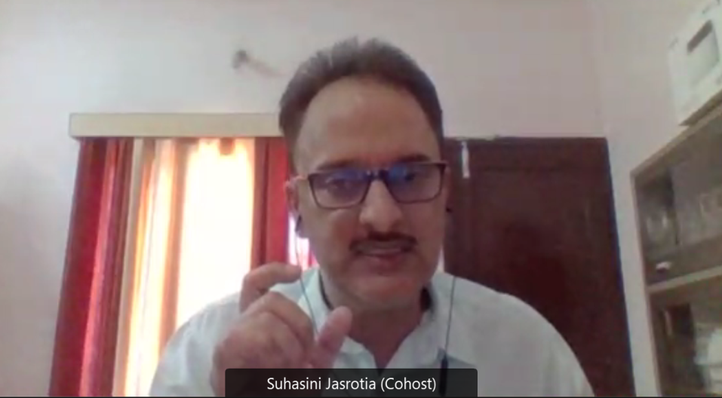

The session commenced with the moderator of the session, Mr. Raghav Parthasarathy, Teaching Associate, CEERA, NLSIU, introducing the resource person for this session Prof. (Dr.) Arvind Jasrotia, Dean, Faculty of Law and Registrar, University of Jammu. The session primarily dealt with the issue of climate wrongs and its associated human rights concerns in light of environmental discourse.

Dr. Jasrotia started his address by referring to the speech given by our Prime Minister Narendra Modi at G7 Summit 2021 relating to the philosophy One Earth-One Health in wake of Covid-19 pandemic. He equated the concept of planetary health significance and human health scenario as interdependent and indivisible in nature along with relating to the idea of ecocentric paradigm. This highlighted the topic of the session as he regarded it to be closely related to the belief of Climate Wrongs and Human Rights.

Explaining the International setting, Dr. Jasrotia explained the functioning of Stockholm Resilience Centre which in the past had undertaken study to demarcate the concept of planetary boundaries with their critical thresholds as tipping elements. These boundaries are differentiated in nine separate entities including Climate Change, Ocean acidification, Land system change, Atmospheric aerosol loading, Freshwater consumption and the global hydrological cycle, Stratospheric ozone depletion, Loss of biosphere integrity (biodiversity loss and extinctions), Nitrogen and phosphorus flows to the biosphere and oceans, lastly Chemical pollution and the release of novel entities. It is pertinent to be noted that these planetary boundaries operate in a non-linear manner wherein if any one element is breached or if one of the tipping elements is crossed it will surely have effect on the other correlated planetary boundaries.

Dr. Jasrotia had substantiated the same with a recent study he had referred to highlighting those three out of the nine planetary boundaries. Climate change, biodiversity loss and interference with the Nitrogen - Phosphorus cycle flows to the biosphere and oceans had already been breached. The human race has entered in the era of anthropocene wherein significant human impact on Earth's geology and ecosystems, including, but not limited to, anthropogenic climate change. It is also called the great mass acceleration era where humans have become a great geological force as was explained by Dr.Jasrotia where law per se and human rights seem to have failed to meet the fast pace of human living. He stressed upon the utility of earth system law and earth system governance as a potent solution towards Climate Change as a best suited response to the lacking international environment law. There had been limited success at the zone treaty but not the climate change where Dr. Jasrotia explained that the climate temperature integrity is two degrees centigrade which has already been breached by us. The UN Mission Gap Report stated that there is a probability that there are chances of crossing three degree centigrade by the end of the twenty first century.

Dr. Jasrotia regarded climate change not only as an environmental or ecological crisis but also as an existential societal crisis. He quoted the report of the Lancet Commission on planetary health which regarded the condition of human health and planetary health inextricably linked to each other. The report had stated that human civilization depends upon human health, flourishing natural systems and judicious use of natural resources. It expressed its concerns on the degradation of natural resources and regarded this condition as peril to the human health and planetary health.

Dr. Jasrotia stressed upon the interaction between climate wrongs and human health by defining human health holistically as the state of physical mental and social wellbeing and not merely an absence of any diseases or infirmity. There should not be any kind of discrimination linked with ensuring societal health to all the inhabitants and regarded such as fundamental rights to be assured by the state positively. Dr. Jasrotia mentioned another study of Lancet on Commission on Climate Change based on the ill effects of climate change posed upon the Human Health due to various natural calamities such as floods, droughts as well as the human related artificial causes of levels of air pollution, displacement, mental anxiety, poor nutrition and forced deforestation. It proclaimed that health effects of climate change are the biggest global threat of the twenty first century and paradoxically if we want to tackle climate change it is considered as the biggest global health opportunity.

As per the UNFCCC basic climate architecture it regards climate change as a common concern of humankind and sets the threshold of two degree Celsius. Dr. Jasrotia stressed upon the belief of climate integrity as IPCC refers to tipping points which have been breached. As per Paris Agreement this limit should not go beyond two degree Celsius as per pre-listed levels and ideally should be restricted to one point five degree Celsius. Dr. Jasrotia highlighted that the same can be deliberated to be achieved by increasing the Nationally Determined Contributions (NDC’s) triple the current times in order to keep the temperature below two degree Celsius. There is a north south divide in context to environmental justice Dr. Jasrotia regarded the North better in terms of living standards and less vulnerability to climate change due to better adaptive policy. In India too we find this division quite easily due to economic disparities and different geographical settings of various Indian states who are more prone to environmental vulnerability. UDHR proclaims that everyone is entitled to social and institutional order and climate change disrupts such a notion and is thus considered as an antithesis to it. He cited Article 3 of UDHR, Article 6 of ICCPR and Article 6 of CRC in order to put forth the idea of vulnerability of populations both India and abroad who are more prone to climate change perils. In Indian context vulnerable groups include those communities that dwell on the coastal areas have poor socio-economic conditions and lack the adaptive capacity.

Dr. Jasrotia imbibed the ideas of climate change litigation wherein the issue related to climate change is directly in concern. He is surprised to express that he does not find any notable climate change litigation in the global south that has highlighted any environmental wrong except the case wherein hydrofluorocarbon is treated as climate pollutant by the National Green Tribunal in India. He backed the idea of an exclusive climate change protection law apart from invoking Article 21 in order to cater to the need of streamlining the course of climate change litigation India. He advocated the formation of umbrella legislation on climate change for better synchronization between various departments and ministries along with current environmental legislations which can be brought under this proposed statute to prevent any kind of procedural slackness and institutional lacunae.

Dr. Jasrotia backed the thought to establish a statutory climate ombudsman in the form of Climate Commission composed of both legal and subject matter experts in order to undertake an in-depth study relating to climate vulnerability from every nook and corner of the country. Innovative governance patterns following bottom-up approach can be employed to ensure the participation of Sarpanch as a part of decentralization of governance in such mechanisms to ensure better identification of climate vulnerable people from their respective villages.

Lastly Dr. Jasrotia had emphasized on the mechanism to evaluate the NDC’s so that there is always progression from the past levels of benchmark in order to be appropriately aligned with the international standards on the corresponding norms to combat global climate change and ensure human rights effectively. Rights based approach needs to be linked with climate vulnerable communities so that positive obligation is casted upon the states to protect them from any probable ill effect due to climate change.

SESSION 5

The Status of Climate Legislation in Australia: The Broader Importance of Legislative Provisions for The Renewable Energy Sector

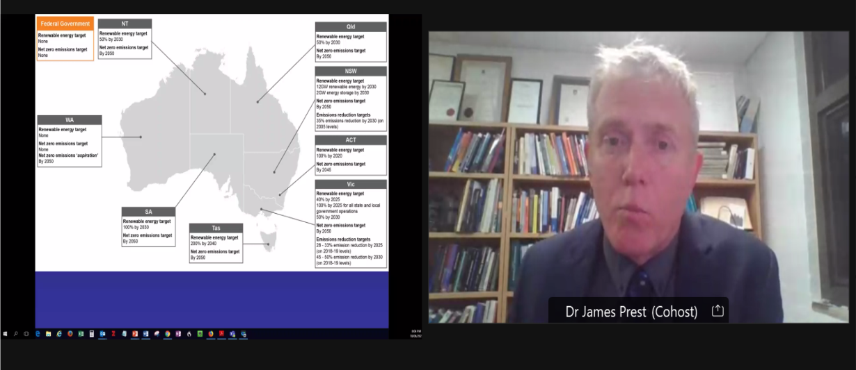

The session commenced with the moderator of the session, Mr. Raghav Parthasarathy, Teaching Associate, CEERA, NLSIU, introducing the resource person for this session, (Dr.) Dr. James Prest, Senior Lecturer, College of Law, Australian National University. The session primarily dealt with the The Status of Climate Legislation in Australia: The Broader Importance of Legislative Provisions for The Renewable Energy Sector.

At the very onset of his presentation Dr. Prest highlighted his ambit which covered the policy reforms in Australian context including legislative measures related to climate change coupled with the idea of reviewing the current electricity laws in light of implementing renewable energy alternatives to combat the same. The map shown in the above picture showing the sub national jurisdictions highlights that there are no national goals of Australia per se in relation to renewable energy targets as the former goals have been fulfilled and thus not incentivizing any further targets to be achieved in future. Dr. Prest laid down that due to the federal conservative politics in power there is a slackness towards achieving energy targets and goals relating to climate change with a sheer reluctance to keep up to the net zero emission target in place. The NDC's have been formed due to the compliance towards UNFCCC but the same are being renewed with some prior amendments from the past which reveals the lack of ambition federally in order to combat climate change. Dr. Prest said on record that federally Australia has some serious problems in response to the phenomenon of climate change.

On the contrary, at the sub national level all the territories have their respective energy target levels with climate change legislation in order to achieve net zero emission by 2050 unanimously. The intent to achieve such a desired target is ensured via legislative means or policy means as deemed fit by the respective state. He pressed upon the idea that legislative means are necessary in order to achieve the prevention of climate change in the longer run. Dr. Prest advocated to establish international climate change consensus in furtherance to the common goal of mitigating climate change. At the same time legislation alone cannot solve the purpose without efficient real time practical solutions in the form of renewable energy prospects to be undertaken by Australia. This involves renewable electricity, transportation and decarbonisation of the Industrial Sector. This can only be ensured as per Dr. Prest when we inculcate to include the concerns on climate change in our national and sub-national electricity laws.

Dr. Prest explained the former national Australian legislation for the pricing of carbon emission named as Clean Energy Act which was primarily about the carbon taxation policy. This was a controversial issue in the political spheres and the then Australian Prime Minister Tony Abott was voted out by the local people on the issue of climate change. He was responsible for the repeal of this carbon pricing taxation regime. Zali Steggall is the former Olympian who took charge post Tony Abott introduced a bill titled Climate Change (Establishing a National Framework for Adaptation and Action) Bill 2020. Although she is a private member of the house and lacks numbers by her side Dr. Prest commended her very intent towards climate change vulnerability. The projected bill by Zali Steggall advocates establishing an independent climate change commission in order to achieve a net zero carbon emission target by 2050. Although Dr. Prest discouraged the long term target and put forth to recognize the midterm target to be achieved in terms of Climate Change. He also advocated to ensure the accountability of the minister in case the targets are not met as per the Nationally Determined Contributions to prevent climate change.

Dr. Prest discussed the sub national legislation relating to prevention of climate change already in operation in the state of Victoria which lies in the south of Australia. Climate Change Act 2017 was formulated by the state of Victoria with the proposed goal of achieving net zero by 2050 along with setting interim targets to be assessed after every 5 year in order to obligate the government to formulate a new improved climate change strategy based on the prior assessment. He expressed the irony that although the state had a robust legislation at work in this regard along which subsequent other renewable sources of energy including wind and hydroelectricity still the usage of brown coal surpassed them in the production of electricity.

Citing the French example Dr. Prest highlighted that in February 2021 France introduced the real climate change legislation which aimed to update and revamp the existing climate change legislations. This included the revision of new targets in terms of achieving net zero condition and introduced the new terminology of climate emergency to respond to the ecologic and climatic emergency. Even the citizens were asked to contribute in the form of recommendations to the government but practically out of 150 suggestions 149 were outrightly rejected by the government which exposed the dual nature towards citizens' voice resulting in widespread public demonstrations. One of the issues in the french climate legislation refers to the colder areas where there are lower standard buildings having a lack of energy efficiency. As per the new legislation such a building cannot be rented out or leased post 2023 and also banned the advertisement relating to fossil fuels. It also aimed to administer a ban on usage of polluting vehicles post 2025. Dr. Prest found these measures as the regulatory having practical application rather than being aspirational in nature.

Dr. Prest cited the ambitious aspirational targets of Climate Change Law 2020(June)enacted by Denmark which aims to cut seventy percent of carbon emission by 2030. He appreciated the integrity relating to determination to use the baseline of 1990 which is the same as stated in the Kyoto Protocol whereas on the other hand Australia had been manipulative to set up their own baseline to the year 2005. This in turn exposes the vital questions of comparability of effort by two nations within their own legislation. In relation to the same contention, Dr. Prest also highlighted the Climate change legislation of Germany which under section. 3 instructed to raise the climate change targets rather than lowering the same while undertaking such measures. It is in sync with the ideology of Paris principle of Progression, the wretched mechanism to avoid any backsliding effect of environmental goals. This helps to avoid the theory of short-term targets to win the electoral mandate which in the longer run is detrimental to the ethos of climate change endeavours.

In the last couple of minutes Dr. Prest explained that paradoxically there has been a boom in the renewable energy market primarily in wind, solar-hydro energy and its enhanced usage even though the relatively negative federal legislative climate. This may be associated with the low institutional cost associated with the renewable sources of energy along with intentions of the market to invest in such energy resources rather than conventional sources. Dr. Prest also laid emphasis on various challenges being faced by the renewable industry namely:
- Concerns and challenges related to the Grid connection processes and technical requirements
- Under Investment in the network capacity to address congestion and constraints.
- Future Market design uncertainty
- Unpredictable and Unhelpful government intervention in energy market
- Lack of integrated long term energy and climate policy
- Concerns and uncertainty among marginal loss factors.

He highlighted the problematic case study of Kennedy Hybrid Renewable Energy Park situated in Queensland Australia due to various grid transmission issues as it was not being allowed to be fully operational to provide electricity in full swing of its generating capacity. Dr. Prest very generously delved in a less traversed area of correlation of electricity law and corresponding Climate Change need in India. The MUST RUN status granted to renewable electricity generators suffer policy implementation lacunae in India. He highlighted the curtailment of certain solar and wind sources of energy due to commercial reasons of prior established conventional energy regime as the entire process lacks the amount of clarity and transparency required to be adopted to ensure seamless implementation.

Dr. Prest then highlighted that in Australian electricity objective also lacked the environment aspects to be linked to it rather than being purely technical in nature. Whereas the UK involves environmental consideration in the electricity law along with other technical and price governing provisions. Same is the scenario with Germany wherein they also included the environmental consideration as a part of their electricity law operational there. He advocated that the same can be undertaken by both Australia and India in order to turn their quest to curb climate change successful in longer run of developmental activities.

SESSION 6

Legislating Climate Change Law - Lessons from South Africa

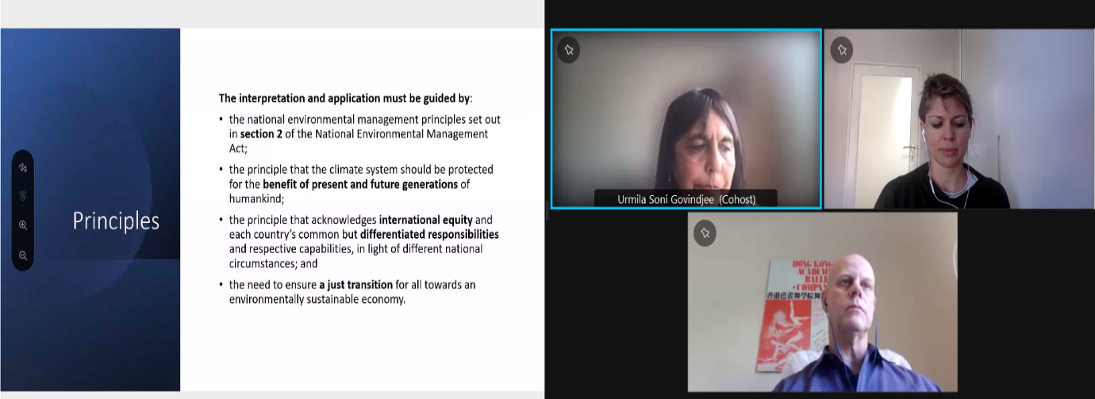

Dr. Urmila Soni Govindjee, Mr Andrew Gilder and Ms. Olivia Rumble together talked on legislating climate change law in South Africa where they outlined the history and important aspects of South African Bill on Climate Change as it sets out the background for the need of legislating climate change in South Africa. They even discussed the implementation of the bill and outlined the advantages of framework legislations as it sets out objects and principles of South African Bill and they summarized the content of the bill chapter by chapter. Then, they focused on the challenges that has been faced by South Africa and the intention behind this was to provide some outline to India.

Dr. Urmila Soni Govindjee talked about the milestones of the Climate Change Policy in South Africa that started with National Climate Change Response Strategy 2004, National Climate Change Response Green Paper 2010 and White Paper 2011 which was culminated in the Draft Climate Change Bill 2018 and The Carbon Tax Act and Regulation 2019. She further proposed draft of Indian bill where she mentioned that focused must be on a framework that will afford climate protection in India which seeks to identify vulnerable communities susceptible to risks of CC and grant protection through measures including a climate risk insurance and ensure climate change preparedness in the country and to boost climate resilience encouraging climate sustainability plans, sectoral intervention and best business practices to encourage mitigation efforts as a complement to the climate adaptation measures, also seeks to create and put in place a climate change structure through the creation of Climate Change Commission for India. The Bill outlines the nature, composition, roles, responsibilities and functions of the Commission vis-à-vis the implementation of the Bill.

She also talked about the aspect of Climate Change Bill 2018 of South Africa that is divided into international, municipalities and provinces, sector department and companies. She pointed out why both India and South Africa wants the framework legislation because it requires a coordinated action across the social, economic and environmental sectors; and across spheres, there must therefore be overarching, and create the necessary framework to enable co-ordinated planning and action, the framework legislation would have greater gravitas within the scheme of multiple legislative instruments, provides the necessary cross-cutting policy certainty to business and industry sector, to make investment decisions that result in GHG reductions and climate resilience, provides single legal reference to determine obligations rather having to refer to multiple statutes. In addition, and in consultation with the relevant sector departments, certain legal instruments, under the jurisdiction of national departments, may benefit from amendments that enable the mainstreaming of climate change consideration into existing planning and decision-making processes. It was recommended that framework legislation be accompanied by a schedule, that outlines suggested amendments

Dr. Urmila explained the key elements that was included in the Preamble of the bill where focus was made on the right to environment, impact of climate change, and responding to climate change. Further, the objective of Climate Change Bill of South Africa where mentioned which is to provide for the coordinated an integrated response, effective management of climate change impact and making fair contributing to global effort of greenhouse gas.

Later, the interpretation and application of Bill was discussed which must be guided by Section 2 of National Environmental Management Act of South Africa, international equity, common but differentiated responsibilities and transition to environmentally sustainable economy.

She also talked about the policy alignment and institutional arrangements for the purpose of achieving the objectives that led to establishment of committees on climate change. Later, how provinces and municipalities are responsible for climate change and what must be the implementation plan was discussed by Ms. Urmila. She talked about national adaptation to the impacts of climate change which included national adaptation planning and strategy and response implementation plan

The greenhouse gas emission and removal were discussed which mentioned sectorial emission targets, carbon budget, how the carbon budget must be allocated and implemented, the phase down and phase out of synthetic greenhouse gas emission and declaration.

She showed how Post 2020 Mitigation System will be applied and what will be the result. Further some general matters were also discussed. Later, the challenges faced by South Africa was talked about like human and technology capacity, structural issues implementation of agenda, non-coordination financial response and shortage of capacity.

Ms. Olivia Rumble dealt with some questions as taking points like the Comparative approaches - India and South Africa, Comments on and practical insights from the South African process, why does South Africa need to respond to climate change, International best practice and legislating for both mitigation and adaptation in a single instrument. She mentioned that working on institutional mechanism will be required for climate change bill in the developed countries there have been more information on the adaptation strategy where she specified mainly on South Africa and Mexico because they are having a strong adaptation component. She mentioned the thinking behind the bill was far more considering it like a framework and the government wanted that to have a broader architecture which had already precise regulation. In India the ministry will allow to sustain the law and flexibility will be maintained and the law will not be outdated with time as climate changes quickly evolving field and having a lot of details to be included like UNFCCC reports, mapping and assessment etc.

Like Mexico climate change act which is different and has included all the details in the substance of the act therefore to be updated with climate change that we need to know the nature of parliament whether it is active parliament or not because of any amendment is required will it pass quickly or will it be impossible to put the detail in the regulation.

Mr Glider stated that it is easier to amend regulation than it is to amend a statute. In the Indian bill of Climate Protection Compensation, the person eligible for climate compensation and ground spawn which compensation must be claimed interesting. He stated that comments were made as such South Africa doesn’t have a political will to give climate change on contrary, they have a climate change bill and have implemented carbon tax etc.

Mr Andrew Gilder dealt with two major important questions: How does South African environmental legislation work? and the role of the Presidential Climate Change Coordinating Committee.

SESSION 7

Keynote Address

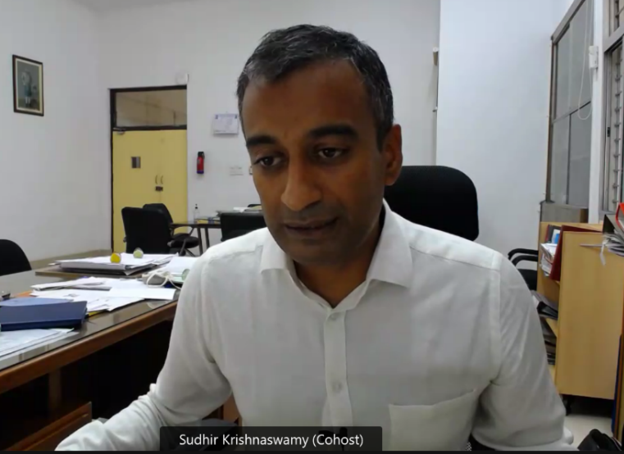
The keynote address on the session was started by Prof. (Dr.) Sudhir Krishnaswamy, Vice-Chancellor, NLSIU, who began by explaining the importance of environmental conservation, especially on a practical level, in the university at NLSIU. There were commitments expressed on behalf of the university to work more on climate change and environmental protection. While discussing the divide in the global north and south on climate change he was quite critical as to the need of the developing countries to balance the burden of climate change at the cost of their development. Dr. Krishnaswamy mentioned that the country's current national aims and commitments are in the right direction towards ensuring its duty to combat climate change through measures like net-zero emission targets and more. Before concluding his talk, he hoped for a more comprehensive effort like a national climate justice plan to coordinate the national struggle.

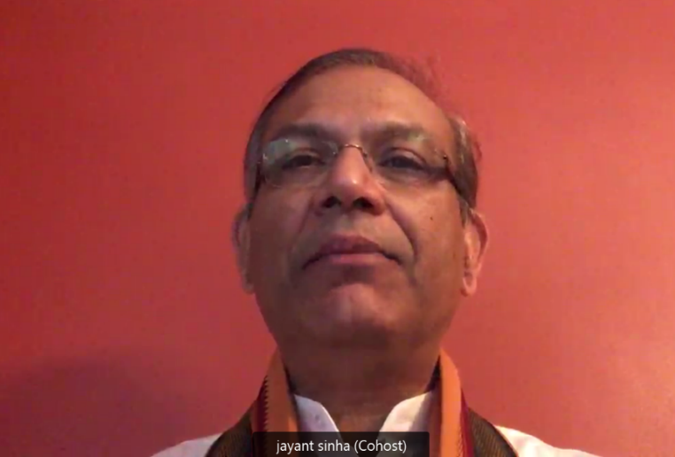
Following this Hon'ble Mr. Jayant Sinha, Member of Parliament (MP), sharing his insight as to his evolving perspective on the environmental challenge, from the perspective of an engineer focusing on efficient usage to resources to concentrate on climate justice globally to now the current stance of viewing the climate challenge as one of survival and competitiveness. Building upon his statement, the increasing impact of climate change on India, especially balancing the need for development and the duty towards the environment was stressed on. Furthermore, Mr. Sinha explained how green technologies can help India, which is currently dependent on brown technology, to technically and economically innovate while recognizing a significant role for the private sector in the initiative. Thus, showing that how net-zero targets of using green tech and climate-sensitive policies can be net positive for India's economic growth.

Going forward, there was a discussion on the private member bill introduced by Mr. Sinha in the parliament to push for net-zero emission targets. He went on to suggest different policy measures like a carbon tax, the creation of statutory bodies, and regulatory mechanisms by the government at the union and state level, along with private industries, to achieve a more robust framework to combat climate change. There was a strong emphasis on the need for public discourse on the topic of climate change, especially at the state level, while also recognizing a need for civil society to work with private industries to create climate-sensitive policies like net-zero emission targets and to promote green finance to support national growth.

SESSION 8

Comparing The European Green Deal Legislation Programme



Following this, the third speaker of the session, Prof. (Dr) Kirk W. Junker, Professor of Law, University of Cologne, Germany, discussed the historical trend of international environmental law from the Rio de Janeiro Earth summit (1992), which aimed at mitigation of climate change to Kyoto Protocols (1997) which focused on adaption and resilience, signalling a change in international environmental law and national perspectives. The discussion moved to explain the political and administrative governance structure of the European Union (EU). Furthermore, variance in environmental jurisprudence between American, European, and Indian jurisdictions was also discussed.

Professor Junker discussed the details of the EU Green Deal, showing EU’s climate-focused initiative through the Climate and Energy Package (CEP) 2007, which managed to reduce emissions by 24% while also ensuring economic growth of 60%. While also, recognizing the failures of the initiative mainly as it was limited in scope and application from certain sectors like aviation. The targets of the EU green deal to reduce carbon emissions by 55% to 1990 levels and being carbon neutral by 2050 were highlighted along with an analysis of the major elements of the EU green deal, namely:
- Clean energy: With the EU focusing on and promoting green technologies like solar and wind
- CO2 Pricing: the measures of the EU to ensure tariffs and taxes to ensure against carbon leakage, especially through international trade with nations having less ambitious environmental policies. However, he did mention how such measures of introducing licenses for exporting countries to trade with the EU to comply with its green deal aren't well-received by many of the countries, namely the BRICS and USA, and claimed as trade disruptions.
- Transport: the EU measures to promote sustainable Transport through the union by promoting and subsidizing electric vehicles.

His session explained the EU's aim to provide finance totalling €1 Trillion at the EU level as well as the National level by compensating industries and incentivizing shift to green and clean technologies. The discussion also highlighted the importance of the EU green deal, especially to nations such as India, as promoting investment in green technology as well as by promoting and raising standards of corporate governance and vigilance.

Before Concluding the session, Prof. (Dr.) Sairam Bhat, Professor of Law, NLSIU, thanked everyone and stressed the importance of the need for stronger measures to combat climate change.

SESSION 9

Climate Institution and Policy



Prof. (Dr.) Navroz K. Dubash began his talk with the help of a PowerPoint presentation. The topic discussed by Prof. Dubash was “Climate Institution and Policy”. He concentrated on addressing how to build a climate ready Indian state. For the better understanding of the audience, he approached this question by introducing the audience to the current institutional work done by the Indian government through the likes of National Solar Mission, Prime Minister’s Council on Climate Change etc. The speaker then brought out the barriers in efficient functioning and full realisation of these national schemes by stating that these institutions have faced hindrance by what Prof. Dubash termed as “Inter-Ministerial Hierarchies”.

As a solution to these problems, he suggested that the climate legislation should have a vision of “equitable low-carbon economic pathways”. Explaining further, he said that low carbon target must go hand-in-hand with economic transition. Further, he explained that a stable and consistent environmental governance must be adopted irrespective of any changes in government/administration. Talking about India’s federal structure, Prof. Dubash explained that the centre and state governments must collaborate in different action plans, program implementations and further mentioned an interesting example to explain this aspect. He said that as an example, the Himalayan states like Himachal Pradesh, Uttarakhand etc can collaborate amongst themselves to tackle specific climate change issues concentrated in the Himalayas. Similarly, the coastal states can also look at tackling rising sea levels, loss of ocean life etc., opined Prof. Dubash.

In this context he explained the need for an independent body between the state and civil society. The speaker proposed a “Low Carbon Development Commission” to address the need of inter-ministerial collaboration. He proposed that the commission must have a multi-stakeholder commission and a technical secretariat tasked with non-executive functioning and feedback and advice to the ministries. Prof. Dubash ended his presentation by proposing an overhaul of the climate governance infrastructure.

Law, Social Impact and Climate Change



Dr. Dilan Thampapillai, bringing in the Australian perspective said that Australia’s actions in the climate change space had left quite a lot to be desired in the international stage. He began his session on social impact of climate change by talking about the social impact of climate change on private law. Dr. Thampapillai explained that social impact gained traction over the past two decades and said that the legal system, especially common law systems are built purely for the for-profit enterprises whose main aim would be to maximise profit. However, not-for-profit and social impact companies do not have a legal system that has evolved with time. Further Dr. Thampapillai explained that a balance must be achieved between evolving the legal systems for these companies and regulating more than what is required as that would cause a social dilemma.

Dr. Thampapillai said that there is a need to come up with some novel and innovative rules in private law for social impact as there could be a lot of agreements/contracts between different government enterprises and private partners that have a significant social impact on communities bearing the brunt of climate change. He further explained that these communities who are vulnerable to climate change are considered as third parties under these contracts and would hence be excluded from seeking damages due to privity of contract. Yet they are directly impacted from it, said Dr. Thampapillai. Further, the speaker suggested that arbitration could be encouraged as an alternative to litigation in these cases. Dr. Thampapillai concluded by stating that social impact sector is a legal grey space in most countries.

Legal and Social Contours of Climate Change

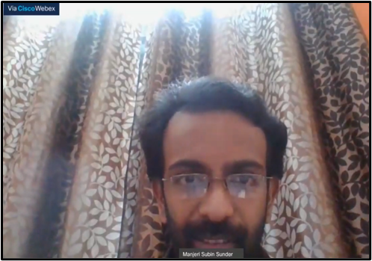
Dr. Manjeri Subin Sunder Raj, started of his presentation, which was the final session for the day, by talking about how the United Nations Framework Convention on Climate Change (UNFCCC) empowers the parties to the convention to protect the environment on the basis of equity. He then explained that the current policy framework does not take into account the negative impact and does not fully help in realising the goal of sustainable development. While considering framing policies and regulations on climate change, social and economic impacts of climate change must also be considered, explained Dr. Sunder Raj. He then went on to mention how the Framework Convention (UNFCCC) and other Human Rights convention had already considered some elements of the social impacts of climate change and that a foundation had already been laid for inclusion of social dimensions in climate change.

Dr. Sunder Raj, further explained that we humans though victims of climate change, tend to forget that we are also the drivers of climate change. Inclusion of social dimensions of climate change could be justified on four grounds, explained Dr. Sunder Raj. Firstly, social dimensions that are already existing albeit in a very crude and elemental way. Secondly, inclusion of social dimensions as a prerequisite to human rights. Thirdly, the effectiveness of climate change policy would be enhanced if social dimensions are completely integrated. Lastly, synergies between climate change agenda and sustainable development & human right agenda should be made, suggested the speaker. Integration of these parameters in climate change policy would bear concrete results in tackling climate change opined Dr. Sunder Raj. To further reiterate his argument, the speaker quoted Article 4 of the United Nations Framework Convention on Climate Change (UNFCCC) which mentions that social considerations must be taken into account while formulating climate change policies albeit not explicitly.

Most environmental impact assessments tend to look at only the environmental and infrastructural impact of climate change and overlook the social impact, the speaker said. Further the speaker explained how aspects of displacement and migrations due to climate change must also be taken into consideration. Explaining further the speaker said that the 1951 Refugee Convention does not recognise climate migrants/climate refugees. To better explain the speaker brought out the facts of the New Zealand refugee case of Ioane Teitiota v. New Zealand. Further, he explained that states should identify the right holders and states must also be held accountable for violations of those social rights. All the policies, regulations and rules should ensure that local communities must be empowered, the speaker said. He then gave the example of Milieudefensie et al. v. Royal Dutch Shell PLC. where the court held that the Dutch government had violated its duty of care towards the citizens.

As a solution, the speaker suggested a better way at assessing social impacts of climate change is through social impact assessments. Secondly, he suggested an inter-ministerial policy coordination for better understanding of social impacts and lastly, he concluded by saying that there needs to be significant investment in human capital.

Following this, Prof. (Dr.) Sairam Bhat concluded the workshop on a positive note with a brief vote of thanks to all the organisers, resource persons and participants.

*****

